# 2.4 (a)

|  | **age** | **%fat** |
| --- | --- | --- |
| **Mean** | 46.444444 | 28.783333 |
| **Standard Deviation** | 13.218624 | 9.254395 |
| **Median** | 51.000000 | 30.700000 |

# 2.4(b)

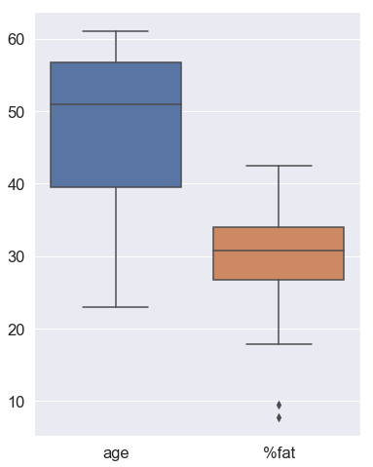

# 2.4 (c)

# 2.8 (a)

|  |  |  |  |  |  |  |  |  |
| --- | --- | --- | --- | --- | --- | --- | --- | --- |
|  | A1 | A2 | Euclidean | Manhattan | Supremum | Cosine | Cosine-Scikit | Cosine-Scipy |
| x1 | 1.5 | 1.7 | 1 | 1 | 1 | 1 | 1 | 1 |
| x2 | 2.0 | 1.9 | 5 | 5 | 4 | 2 | 3 | 4 |
| x3 | 1.6 | 1.8 | 3 | 3 | 3 | 4 | 4 | 2 |
| x4 | 1.2 | 1.5 | 2 | 2 | 2 | 5 | 2 | 3 |
| x5 | 1.5 | 1.0 | 4 | 4 | 4 | 3 | 5 | 5 |

# 2.8 (b) – used L2 norm

|  |  |  |  |  |  |
| --- | --- | --- | --- | --- | --- |
|  | A1 | A2 | A1norm | A2norm | Euclidean |
| x1 | 1.5 | 1.7 | 0.661622 | 0.749838 | 1 |
| x2 | 2.0 | 1.9 | 0.724999 | 0.688749 | 4 |
| x3 | 1.6 | 1.8 | 0.664364 | 0.747409 | 2 |
| x4 | 1.2 | 1.5 | 0.624695 | 0.780869 | 3 |
| x5 | 1.5 | 1.0 | 0.832050 | 0.554700 | 5 |